Programming Concepts - Tutorial 2
HIT265 – C Programming
Question 1
Write the adjacency matrix for each graph in Figure 1.
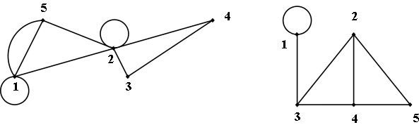
(a)
(b)

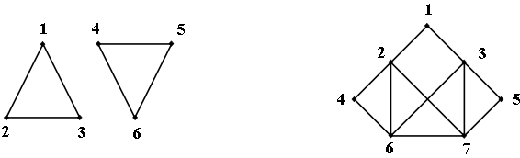
(c)
(d)

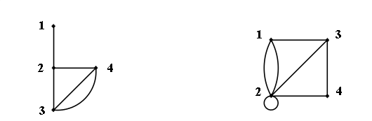
(e)
(f)

Figure 1
Question 2
For the graph in Figure 1(d), determine 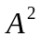 to find the number of paths of length 2 from node 2 to node 6.
Question 3
For the graph in Figure 1(a), count the number of paths of length 3 from vertex 5 to vertex 2. Check your answer by calculating 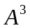.
Question 4
The adjacency matrix for an undirected graph is given in lower triangular form by
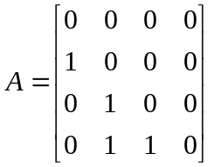
Draw the corresponding graph.
Question 5
Draw the undirected graph represented by the adjacency list in Figure 2.
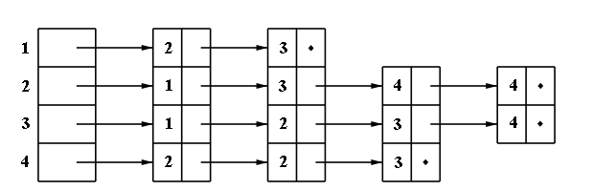

Figure 2

